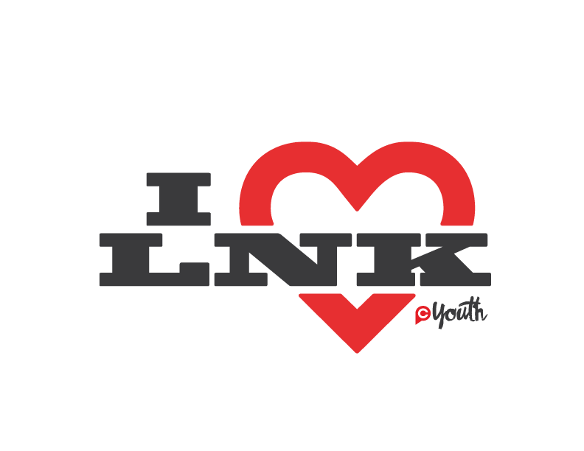
July 12-17,2020

(Must be 19 or older) Please return to the Resource Table on Wednesday night, or the CP Youth cart on the weekend by April 1st!

CONTACT INFORMATION
Name: ________________________ ____________________ ____________________
^{(First)} ^{(Middle)} ^{(Last)}

Street Address: _____________________________________________________________
^{(Include Apt # or PO Box #)}

Zip Code:___________________ Age: _____________ Birth Date: ______/_____/_______
Email: _____________________________________________________________________
Best Contact Phone: _____________________________ Check One: ☐ Mobile ☐ Home
T-shirt Size: ☐S ☐M ☐L ☐XL ☐XXL ☐OTHER:
Would you like one of your shirts to be a sleeveless? Yes _______ No _______
EMERGENCY CONTACT
First & Last Name: ___________________________________________________________
Street Address: ____________________________________________________________
Zip Code: ___________________ Best Contact Phone: _____________________________
Relationship: _______________________________________________________________
HEALTH INFORMATION
What describes your current physical health? ☐ Excellent ☐ Good ☐ Fair ☐ Poor
Clinic/Doctor: ____________________________ Phone #: __________________________
Office Address: _____________________________________________________________
Do you have insurance? ☐Yes ☐ No
Insurance Company _________________________Phone #__________________________
Medicine you will be bringing _________________________________________________
Are all immunizations current with state requirements? ☐ Yes ☐ No If no, please explain: ___________________________________________________________________________
Date of last medical exam? __ /__ /__ Food allergies? _____________________________
History of: Heart trouble ___Diabetes ___Fainting ___ Asthma ___ Allergies___
Nose bleeds ___ Headaches ___ Other : ________________________________________
Mobility limitations/Restrictions ___________________Disabilities ___________________
FINALIZING INFORMATION
Do you currently hold a membership at the YMCA? Yes _______ No _______
I certify that the information included in this application is true and I have answered each question completely. I also understand my application is subject to approval and does not insure my participation of I Heart Lincoln.

Print Name: _______________________________________________________________
Signature: _____________________________________________ Date: ____/____/_____
CONFIRM AVAILABILITY
Please check one to indicate your time commitment the week of I Heart 2020:

☐ All day, everyday ☐ All mornings ☐ All afternoons ☐All evenings
☐ Other _________________________________________________________________

CONFIRM SERVING AREA
Please check area of serving you are interest in:
☐ Assist Team Leader ☐ Kitchen Crew ☐ Laundry ☐ Morning Worship
☐ Van Driver ☐ Undecided

Comments: _______________________________________________________________________________________________________________________________________________________________________________________________________________________________________________________________________________________________________________________________________________________________________________________

***PLEASE TEAR OFF THIS SHEET AND KEEP FOR REFERENCE***
MARK YOUR CALENDAR
I Heart 2020: July 12-17
ADDITIONAL INFORMATION
Full-time team: There is no cost. Included in full-week participation: meals, housing, t-shirt, water bottle, lanyard, drawstring bag, and admission to all evening activities.
Part-time team: There is no meal cost, but we ask that you pay your admission if you attend an evening activity. Meals and an I Heart LNK t-shirt are included.
EMERGENCY CONTACT NUMBERS
Christ Place Church Office: 402-421-1111
Youth Pastor, Bruce Riddle: 402-304-8665
I Heart LNK Coordinator, Sarah Bennetts: 402-902-9881
I Heart LNK Coordinator, Brea Diaz: 402-681-3852
PACKING LIST
☐ Clothes for evening activities.
☐ Appropriate Sleepwear
☐ Sleeping Bag and Pillow
☐ Air mattress (Optional)
☐ Swimsuit/Towel
☐ Shower Towel/Toiletries/Shower Shoes
☐ Tennis Shoes
☐ Hat
☐ Pants/Shoes that can get dirty
☐ Personal Medications
☐ Bible
☐ Extra spending money for snacks if desired.

